**SERVICES**

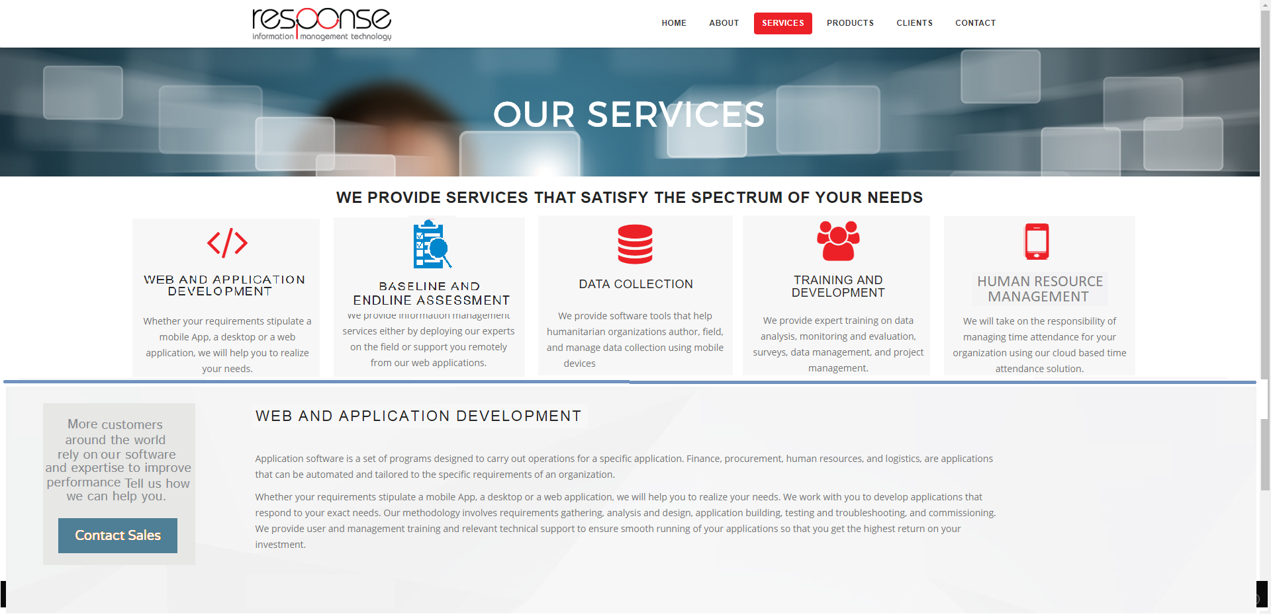

#### web and APPLICATION DEVELOPMENT

Whether your requirements stipulate a website, a mobile App, a desktop or a web application, we will help you realize your needs. We work with you to develop applications that respond to those exact needs. We provide user and management training and relevant technical support to ensure smooth running of your applications so that you get the highest return on your investment.

Web development refers to the tasks associated with building, creating, and maintaining websites. The process includes aspects such as web design, web content development, web publishing, web programming, and database management.

Application development is the process of creating software applications like finance, procurement, human resources, and logistics that are automated and tailored to the specific requirements of an organization. It includes requirements gathering, analysis and design, user interface design, programming, testing, troubleshooting and deployment.

We develop applications using open source technology based on PHP and MySQL combined. Using such development tools, applications can be built with clean and simple usability, complex functionality, speed, power and scalability. These development tools and database servers are free and do not require licensing costs.

DATA COLLECTION

We provide software tools that help humanitarian organizations author, field, and manage data collection. With new mobile data collection tools your organization can set up checks, hints to help the interviewer, easy ways to retrieve the data from your mobile system, and upload everything into your computer.

Empower your field workers and increase their productivity with mobile forms. Build custom designed forms or surveys on a mobile device and collect data in real time and send it directly to your database, then aggregate the collected data and finally extract the results in suitable report formats.

More and more organizations are using mobile devices to collect data in the field. Response*COLLECT®* is a tool that allows data collection using mobile devices and data submission to an online database. The data collection process can be streamlined by replacing traditional paper forms with electronic forms that allow text, numeric data, GPS, photo, video, barcodes, and audio uploads to an online server.

Response*COLLECT®* is a free and open-source tool which helps organizations author, field, and manage mobile data collection solutions. Response*COLLECT®* is ideal for socio-economic surveys with GPS locations and images. We can also use other tools like ODK and KoBo.

TRAINING AND DEVELOPMENT

What is good for people is good for the organizations in which they work. Training aims at improving the performance of employees and builds their self-esteem by impacting them with new skills that increase their contribution to the workplace. Organizations want their employees to be are engaged with their mission, values and vision and who have the skills needed to improve performance. Investing in your workforce improves loyalty and staff retention. Our training programs can be tailored to strengthen specific skills that particular employees need to improve.

We provide expert training on data analysis, monitoring and evaluation, surveys, data management, and project management. Our training activities energize, motivate, and help participants to retain content. Our trainers are:

* Management Consultants
* Project managers
* IT Specialists
* M&E experts

We provide on-site face-to-face training or distant online training tailored to your requirements. We deliver training in the field or in office environments to facilitate your specific situation.

manage human resourceS

HR software simplifies and optimizes human resources management by automating manual tasks, and keeping information orderly. Manage the recording, controlling and monitoring of employees using our web application and mobile app. We provide Human Resource Management to effectively track your employees both in the office and in the field. We will take on the responsibility of managing HR for your organization using our cloud-based ResponseHRMS® platform which consists of six main components: Personnel Information (Employee File) Management, Leave Management, Time & Attendance, Payroll, Asset Management, and Performance Management. We provide your organization with a comprehensive, cloud-based, user friendly, and robust solution using the software as a service (SaaS) model. You do not need any hardware and software installation and maintenance: SaaS works like a utility (water or electricity), so you only pay for what you need, and hosting on the cloud is powered by Amazon, therefore we guarantee, data security, reliability and performance to the highest levels.

BASELINE AND ENDLINE ASSESSMENT

Baseline is an important component of the evaluation process as it provides information on the predominant conditions of the context and the people for which the program is intended, before programming begins. Endline assessments are conducted at the end of a programme or intervention, and are intended to measure the outcomes or impact of that intervention.

Response Information Management is a social enterprise that is specialized in providing project evaluation services to the humanitarian community operating in crisis zones. Our team members are experienced in designing and implementing innovative participatory evaluation methods in a wide range of contexts and programmes.

We focus on using the methodologies that best reflect the outcomes of projects and thus reflect on the performance of the intervention and its impact on the target beneficiaries. We believe that only through strengthening the data collection, interpretation and the information dissemination processes, and by focusing on evaluating information, can the humanitarian and development interventions guarantee quality and accountability.

**products**

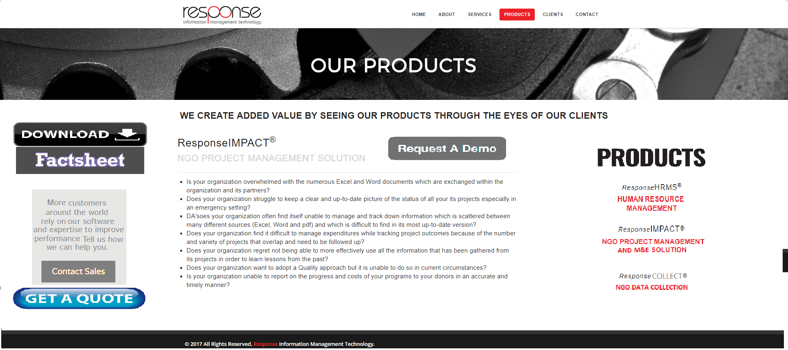

Products not done yet………………………………….

**clients**

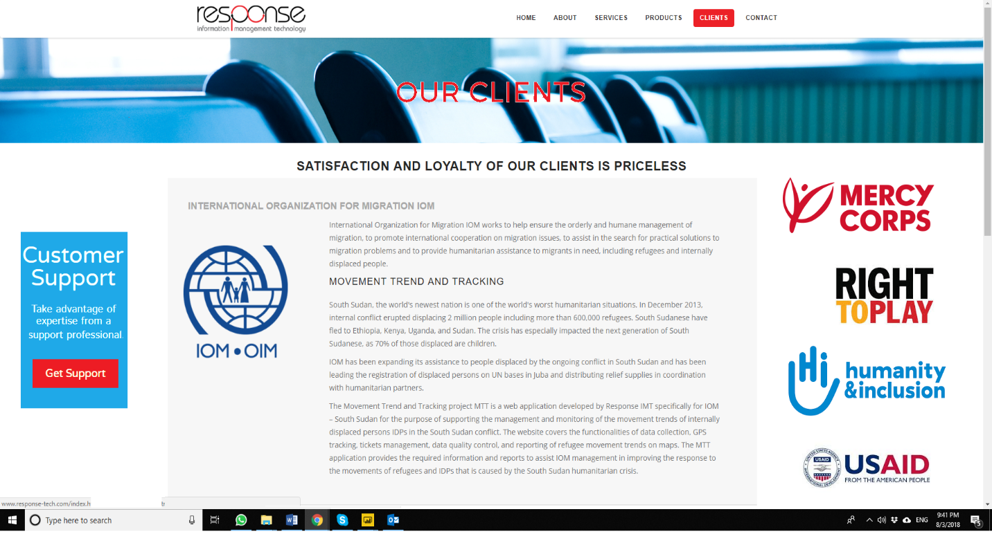

**IOM INTERNATIONAL ORGANIZATION FOR MIGRATION**

International Organization for Migration IOM works to help ensure the orderly and humane management of migration, to promote international cooperation on migration issues, to assist in the search for practical solutions to migration problems and to provide humanitarian assistance to migrants in need, including refugees and internally displaced people.

##### In December 2013, internal conflict erupted in South Sudan displacing 2 million people including more than 600,000 refugees. IOM has been expanding its assistance to people displaced by the ongoing conflict in South Sudan and distributing relief supplies in coordination with humanitarian partners.

##### MTT MOVEMENT TREND AND TRACKING portal

MTT is a web application developed by Response specifically for IOM – South Sudan to support the management and monitoring of the movement trends of internally displaced persons IDPs in the South Sudan conflict. The web portal covers the functionalities of data collection, GPS tracking, tickets management, data quality control, and reporting of refugee movement trends on maps.

**RIGHT TO PLAY**

Right To Play is a global organization, using the transformative power of play to educate and empower children and youth. Through playing sports and games, Right To Play teaches children essential life skills that help them overcome the effects of poverty, conflict and disease so they can create better futures and drive lasting social change in their communities and beyond.

**ResponseIMPACT® NGO Project Management and M&E Solution**

Right To Play contracted Response to install and commission ResponseIMPACT® for its office in Jordan in 2015, and again, for its office in Lebanon in 2016. Data gathering, data migration and training on the use of the application was successfully completed by Response.

**mercy corps**

Mercy Corps is a global [non-governmental,](https://en.wikipedia.org/wiki/Non-governmental_organization) [humanitarian aid](https://en.wikipedia.org/wiki/Humanitarian_aid) organization operating in transitional contexts that have undergone, or have been undergoing, various forms of economic, environmental, social and political instabilities. Mercy Corps proposes a mission to alleviate suffering, poverty and oppression by helping people build secure, productive and just communities. Its programs range from long-term market system development to short-term emergency response programs.

**Impact Evaluation**

In 2016, Mercy Corps contracted Response to perform a consultancy with the purpose of providing an independent analysis of the results of data collected through programing and to ensure the quality and credibility of the results. To achieve this aim, Response consultants completed a pre-post analysis and interpretation of quantitative data for Jordan, Lebanon and Syria

**humanity & inclusion (Handicap International)**

Humanity & Inclusion is an independent and impartial organization working in situations of poverty and exclusion, conflict and disaster. HI works with people with disabilities and vulnerable populations, taking action in order to respond to their essential needs, improve their living conditions and promote respect for their dignity and fundamental rights. HU runs programs in health and rehabilitation and social and economic integration.

**Endline Evaluation**

In 2017, HI contracted Response to conduct a consultancy to lead the development of an end-line evaluation reflecting the results of HI intervention in Dhlail and Hallabat. This end-line evaluation contributed to measuring the impact of the community awareness campaign in the pilot area.

**usaid – Us agency for international development**

USAID is the world’s premier international development agency and a catalytic actor driving development results. The agency provides development assistance to help partner countries on their own development journey to self-reliance – looking at ways to help lift lives, build communities, and establish self-sufficiency. USAID works in over 100 countries to promote global health, support global stability, provide humanitarian assistance, catalyze innovation and partnership, and empower women.

**Tashbeek web portal**

In 2018 USAID contracted Response to develop Takamol's social platform, Tashbeek. This web portal engages women from the various communities around Jordan in a safe and open dialogue, allowing them to discuss their issues and to receive both support and feedback from their peers.

**contact**

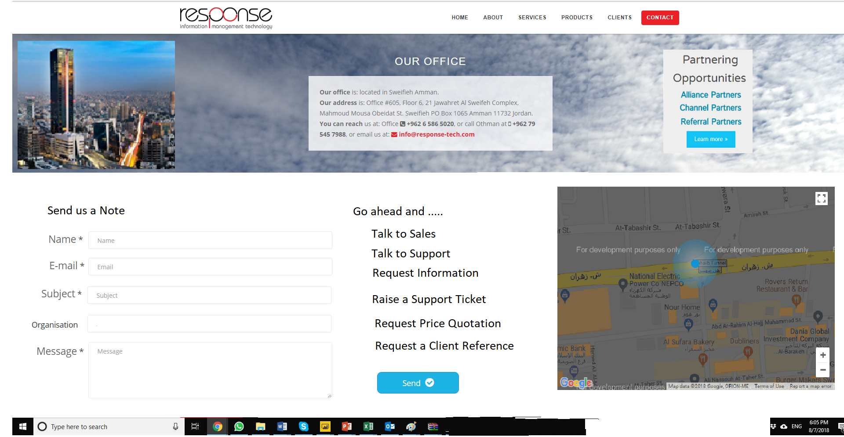

**partners**

